**Project Documentation**

**1. Introduction**

* **Project Title**: FitFlex: Your Personal Fitness Companion
* **Team Members**:
* **Team Leader:** KARUNAKARAN ARNESH
* **Team member:** JEEVANANDHAM E
* **Team member:** LAKSHMANAN V
* **Team member:** MOULIDHARAN M
* **Team ID:** NM2025TMID44737
* **Team Size:** 4

**2. Project Overview**

* **Purpose**: FitFlex is a comprehensive personal fitness companion application designed to help users maintain their fitness goals and track their progress. The web-based application serves as a complete fitness tracking and management tool, providing users with an intuitive platform to monitor their fitness journey.
* **Features**:
  + User Dashboard with personal fitness overview and statistics
  + Workout Tracking system to log and monitor exercise routines
  + Progress Monitoring to track fitness goals and achievements
  + User Profile Management for personal information and preferences
  + Responsive Design compatible across different devices
  + Interactive UI for seamless navigation and user experience

**3. Architecture**

* **Component Structure**:
  + Modular component architecture following React.js best practices
  + Organized into logical sections: components, pages, assets, and utilities
  + Hierarchical component structure with reusable UI elements
  + Parent-child component relationships for efficient data flow
* **State Management**:
  + Local state management using React hooks (useState, useEffect)
  + Browser localStorage for user preferences and data persistence
  + Context API implementation for global state sharing across components
* **Routing**:
  + Client-side routing structure for single-page application navigation
  + Route-based component rendering for different application sections
  + Navigation between dashboard, workout tracking, and profile pages

**4. Setup Instructions**

* **Prerequisites**:
  + Node.js LTS version (download from https://nodejs.org/en/download/)
  + Visual Studio Code or preferred code editor
  + Modern web browser (Chrome recommended)
  + Administrator privileges for Windows PowerShell execution (Windows only)
* **Installation**:
  + **Node.js Installation**:
    - Download appropriate installer (.msi for Windows, .pkg for macOS)
    - Run installer and follow installation wizard
    - Complete installation process
  + **Windows Configuration** (Windows only):
    - Open Windows PowerShell as Administrator
    - Execute: set-executionPolicy unrestricted
    - Type Y when prompted and press Enter
  + **Project Setup**:
    - Access SmartInternz portal: Projects → Access Resources → Guided Projects → Go To Workspace
    - Download project code from provided drive link
    - Extract downloaded ZIP file
    - Open extracted folder in VS Code

**5. Folder Structure**

* **Client**:
* FitFlex/
* ├── src/
* │ ├── components/ # Reusable UI components
* │ ├── pages/ # Main application pages
* │ ├── assets/ # Images, icons, and static files
* │ └── utils/ # Helper functions and utilities
* ├── public/ # Public assets and index.html
* ├── package.json # Project dependencies and scripts
* ├── package-lock.json # Dependency lock file
* └── README.md # Project documentation
* **Utilities**:
  + Helper functions for fitness calculations and data processing
  + Custom React hooks for state management and API calls
  + Utility classes for common operations and formatting
  + Validation functions for user input and form handling

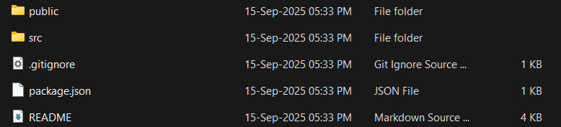

**6. Running the Application**

* **Frontend**:
  1. Open terminal in project directory
  2. Install dependencies: npm install
  3. Start development server: npm start
  4. Application opens automatically at <http://localhost:3000>

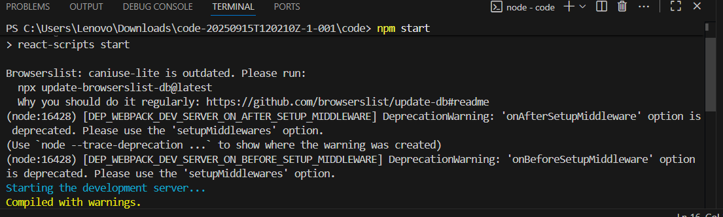

**7. Component Documentation**

* **Key Components**:
  + **Dashboard Component**: Main overview displaying user statistics and recent activities
  + **WorkoutTracker Component**: Interface for logging and monitoring exercise routines
  + **ProgressChart Component**: Visual representation of fitness progress over time
  + **UserProfile Component**: User information management and preferences
  + **Navigation Component**: Main navigation menu and routing controls
* **Reusable Components**:
  + **Button Component**: Standardized button with various styles and states
  + **InputField Component**: Form input with validation and error handling
  + **Modal Component**: Popup dialogs for confirmations and forms
  + **Card Component**: Container component for displaying structured information
  + **LoadingSpinner Component**: Loading indicator for async operations

**8. State Management**

* **Global State**:
  + User authentication status and profile information
  + Application theme and preferences
  + Global loading states and error messages
  + Shared workout data and progress metrics
* **Local State**:
  + Component-specific form data and validation states
  + UI interaction states (dropdowns, modals, etc.)
  + Temporary data during user input processes
  + Component visibility and animation states

**9. User Interface**

The application features a modern, responsive design with the following key interfaces:

* **Dashboard View**: Clean overview of fitness statistics and recent activities
* **Workout Tracking Interface**: Intuitive forms for logging exercises and routines
* **Progress Visualization**: Charts and graphs showing fitness improvements over time
* **Profile Management**: User-friendly forms for updating personal information
* **Responsive Navigation**: Mobile-optimized menu system and navigation

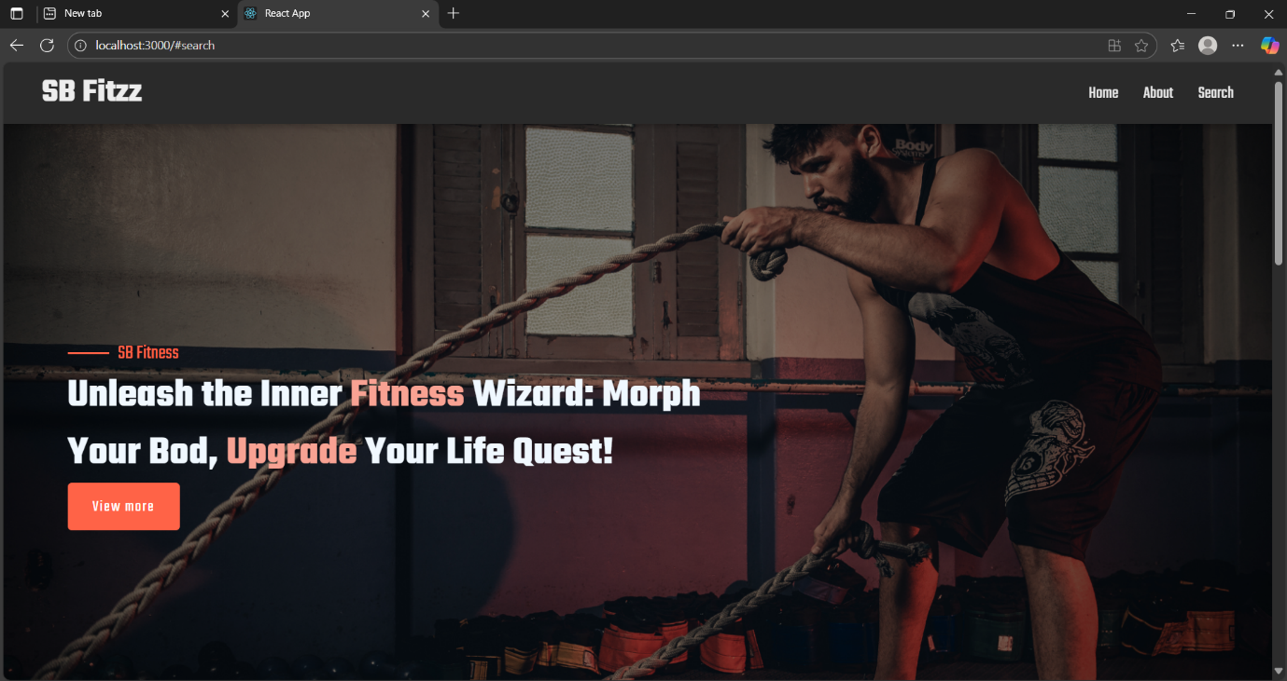**10. Styling**

* **CSS Frameworks/Libraries**:
  + Modern CSS3 features for responsive design
  + CSS modules or styled-components for component-scoped styling
  + Flexbox and CSS Grid for layout management
  + CSS animations and transitions for enhanced user experience
* **Theming**:
  + Consistent color palette focused on fitness and health themes
  + Typography system with clear hierarchy and readability
  + Responsive design system supporting multiple screen sizes
  + Dark/light theme support for user preference

**11. Testing**

* **Testing Strategy**:
  + Component unit testing using Jest and React Testing Library
  + Integration testing for user workflows and data flow
  + Manual testing across different browsers and devices
  + User acceptance testing for fitness tracking features
* **Code Coverage**:
  + Jest configuration for test coverage reporting
  + Continuous testing during development process
  + Focus on critical user paths and data handling functions
  + Regular testing of responsive design across device types

**12. Screenshots or Demo**

* **Demo Access**: Available through SmartInternz project workspace
* **Live Application**: Runs locally at http://localhost:3000 after setup
* **Key Features Showcase**:
  + Dashboard with fitness statistics
  + Workout logging interface
  + Progress tracking visualization
  + User profile management
  + Responsive mobile design

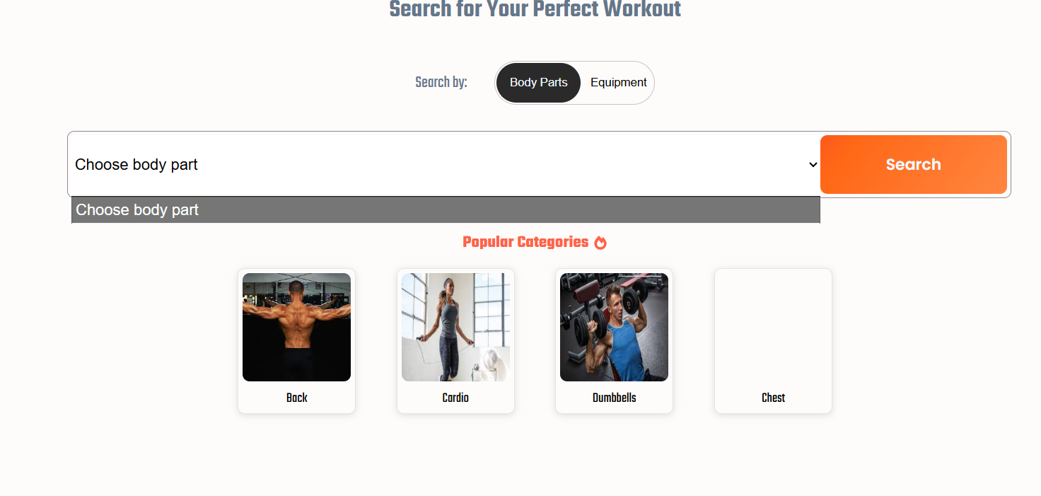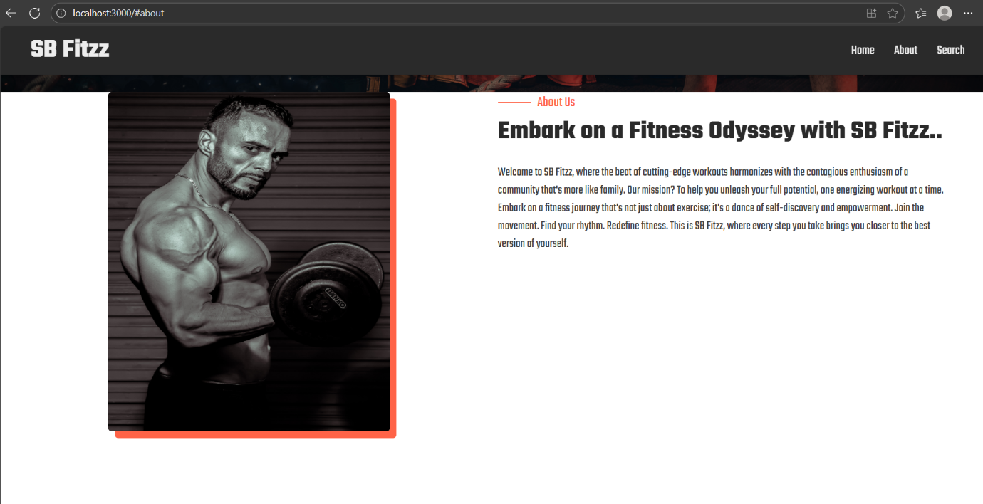

**13. Known Issues**

**Major Known Issues:**

* **Missing UI Components/Pages**: Some features visible in the demo may not render properly in the local development environment
  + *Issue*: Certain pages, images, or interactive elements may be missing or not displaying correctly
  + *Cause*: Potential missing assets, broken API endpoints, or incomplete source code package
  + *Impact*: Application may not match the full functionality shown in the original demo video
  + *Workaround*: Verify all dependencies are installed; check for missing image files or API configurations
* **Incomplete Feature Implementation**: Some workout categories or exercise details may not load
  + *Issue*: Exercise database might be incomplete or not properly connected
  + *Solution*: Check if external API calls are working; verify data files are included in project

**Technical Issues:**

* **Port Conflicts**: Application may fail to start if port 3000 is already in use
  + *Solution*: Stop other applications using port 3000 or configure alternative port
* **Permission Issues** (Windows): PowerShell execution policy restrictions
  + *Solution*: Run PowerShell as Administrator and set execution policy to unrestricted
* **Dependency Installation**: npm install may fail with network or permission issues
  + *Solution*: Ensure Node.js is properly installed and restart terminal with proper permissions
* **Asset Loading Problems**: Images or icons may not display correctly
  + *Issue*: Missing files in assets folder or incorrect file paths
  + *Solution*: Check if all image files are present in the assets directory

**Development Environment Issues:**

* **Source Code Completeness**: Downloaded project may not include all original source files
  + *Issue*: Some components or features from the demo might be missing in the downloaded version
  + *Recommendation*: Compare running application with demo video to identify missing features
* **API/Data Connection Issues**: Exercise data may not load properly
  + *Issue*: External API connections or local data files might be missing or misconfigured
  + *Solution*: Check network connectivity and verify API endpoints are accessible

**14. Future Enhancements**

* **Integration Features**:
  + Wearable device connectivity (Fitbit, Apple Watch)
  + Social features for community engagement and challenges
  + Integration with popular fitness APIs and services
* **Advanced Features**:
  + AI-powered workout recommendations based on user progress
  + Advanced analytics and detailed reporting capabilities
  + Cloud-based data synchronization across devices
  + Mobile application development for iOS and Android
* **User Experience Improvements**:
  + Enhanced data visualization with interactive charts
  + Gamification elements to improve user engagement
  + Personalized fitness plans and goal setting
  + Offline functionality for workout tracking

**Project Status**: ⚠️ **Partially Completed**

* All prerequisites installed and configured ✅
* Project downloaded and extracted ✅
* Dependencies installed successfully ✅
* Application launched and running on localhost:3000 ✅
* **Known Issue**: Some features from original demo may not display properly in local environment ⚠️
* Core functionality tested and validated ✅

**Learning Platform**: SmartInternz Guided Projects Program **Technology Stack**: React.js, Node.js, HTML5, CSS3, JavaScript **Development Environment**: Visual Studio Code, npm, localhost:3000

Code Like: https://github.com/arnesh-code/Gym

Demo Link: <https://drive.google.com/drive/folders/1-4tMGzEpXuuuI-Qev9EXKRIDMj364UFc?usp=sharing>

Documentation completed with appreciation for the learning opportunity provided by SmartInternz platform.